**Date ECC Reference**

**DDMMMYYYY GA??**

**Scope**

This document is a **risk assessment** associated with the “**{Name}**” governance action that will impact the state of the Cardano network and its associated ecosystem.

The risk assessment is from the perspective of the Eastern Cardano Council (ECC), fulfilling its role as a member of the Interim Constitution Committee.

**Management Framework**

See the “ECC Risk Management Framework for Cardano Governance” document.

**Risk Register**

See the [ECC Risk Register for Cardano Governance Sheet](https://docs.google.com/spreadsheets/d/1DoHEkW4-Zu-8L92aINKcXpv1OCl7DvJFr9r9bBzEkYo) for a list of previously identified risks.

Risks are identified and rated using the following matrix based on *Likelihood* and *Consequence*, resulting in a *Risk Rating*.

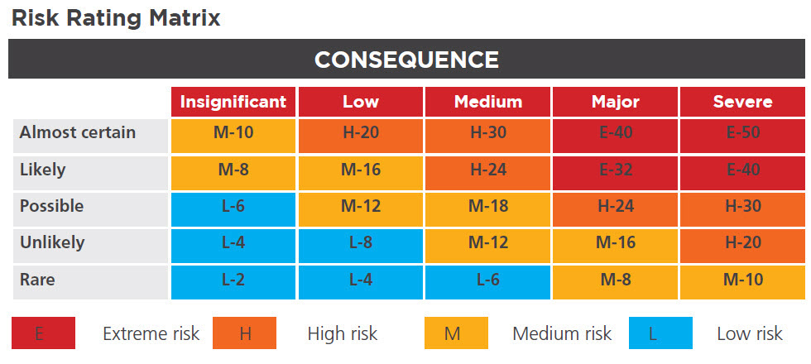

As a guiding principle the ECC will vote yes on governance actions that impact the Cardano ecosystem as constitutional, that contain risks that are:

1. Rated as **“Medium”** or **“Low”**,
2. Rated as **“High”** and have a **contingency plan** to deal with the associated risk should it arise.

**Key Risks Relating to this Governance Action**

| **#** | **Description** | **Likelihood /**  **Consequence** | **Rating** As-Is without Controls | **Treatment**  Accept, Reduce, Transfer, Avoid |
| --- | --- | --- | --- | --- |
| 1 |  |  |  |  |

**Key Risk Scenarios & Analysis**

As part of risk / threat analysis.

See *References* section at the end of this document for supporting information.

**Risk #1**{Risk Description}

**Risk Analysis**

| **#** | **Scenario** | **Description** | **Comments** |
| --- | --- | --- | --- |
| A1.1 |  |  |  |

**Risk Controls & Contingency Plans**How to reduce the risk rating level to ECC acceptable level if treatment is “Reduce”, or Contingency plan if treatment is “Accept”.

| **#** | **Controls (if Reducing) or Contingency Plan (if Accepting)** | **Risk Rating** With Control or Contingency Plan |
| --- | --- | --- |
| C1.1 |  |  |

**References**

For use with risk assessment.